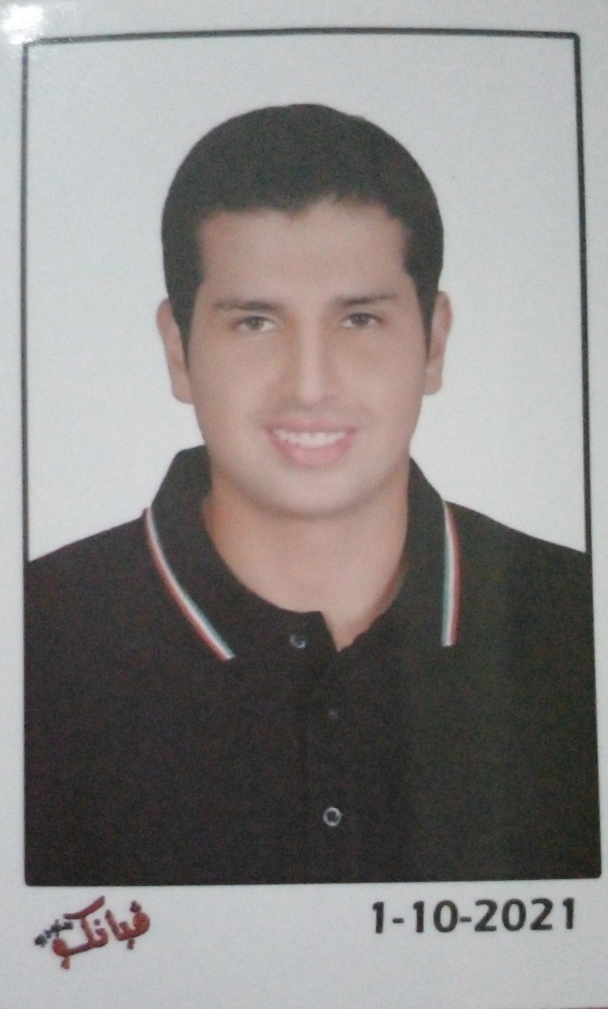

CURRICULUM VITAE

Mohamed Sayed Mohamed Mohamed Abd El Kawy…………
Personal Information
- Date of Birth: 15/1/2003
- Nationality: Egyptian
- Religion: Moslem
- Personal Tel.: N/A Mob: +2-01287025435
- Home: 034204640
Al Mahmudiyah Canal Road, Karam compound Burj Al Salam
- Email: ms1701240@gmail.com
Current Occupation
Fresh graduated
Education and Academic Degrees
Bachelor of Law (2025) | Overall rate of appreciation: Good  Specialization: Law  Institute: Faculty of Law, Alexandria University
Language & Computer Skills
- Arabic: Native
- English: Good
- French: Beginner
- Computer: Good
Teaching and Research Topics
Undergraduate:  Courses | Islamic Sharia - Constitutional Law - Criminal Law - Civil Law - Administrative Law - Civil Procedure - Commercial Law - International Law - Criminal Procedure - Labor Law - Maritime Law - Air Law.
Skills |  | Language, Computer.
Certificate of courses in which I Participate
A course entitled (web designer) Digital Egypt Youth (DEY)- Creative Innovation Hubs (August 2025)
Link: https://drive.google.com/file/d/1E3ZTvwxmfYC6DDtZ92h_h4h8uWh5OxVW/view?usp=drive_link

A course entitled game development using unity (August 1, 2025)
A course entitled development 3 D games on unity game engine
(August 1, 2025)
Link:
https://drive.google.com/file/d/1kAn2gg83LZZpkoMqISKSEMHDqplphOJj/view?usp=drive_link

A course entitled programming in C Sharp (July 2, 2025)
Link:
https://drive.google.com/file/d/1xhgaaAlJ2JL_nTncKNyeqB025ERLOQsb/view?usp=drive_link

A course entitled A1 level course in German (August 1, 2022)
Link:
https://drive.google.com/file/d/12UanfkgV3pJeO9cfSNkYeEcR94IGnQlL/view?usp=sharing

A course entitled Basics of exercising at home and at the gym (June 2, 2020)
Link:

https://drive.google.com/file/d/1e1dhUHngmQsfY_zA_PZFbaRVRv4fThQR/view?usp=sharing

A course entitled A2 level course in English (August 1, 2025)
Link:
https://drive.google.com/file/d/1TEfhKCoveqRmwsjAPbwJU2EopysVBp5_/view?usp=sharing

A course entitled ITIDA Gigs 3-Month Freelance Training Program (June 20,2026)
Link:

https://drive.google.com/file/d/1VgDe0BmrYyC99LSoRwaqy1u5mMHzoJRb/view?usp=sharing

A Course Basic First Aid Skills Training (July 12,2023)
Link:

https://drive.google.com/file/d/1rcSTpHCKcqMQ0aI8V0RP8mBqCf4mXurR/view?usp=sharing

Front-End Development Course -Gig Skill Boost Program (April 25 ,2026)
Link:
https://drive.google.com/file/d/1u0L86ofvun3mtiZDvgS1IOPRLK9VyKoX/view?usp=sharing

Completed a 30-day intensive training covering Software Life Cycle Models, Database Concepts & SQL, ERP Systems, Web APIs & JSON, and modern tools like React and Flutter (July 21 ,2026)

Link: https://drive.google.com/file/d/1i0x2ofrC-c40hm--D5KnXvrcVWFNbJ83/view?usp=sharing
-

Technical Skills

Scripting & Programming Language

- C#, Html, CSS, JavaScript, TypeScript

Frameworks & libraries

- Bootstrap, Tailwind, React.js, Next.js

Additional Skills
- Unity Game Developer

Sports Experience

Football Coach
- Coached at Kabo club
- I specialize in developing goalkeepers’ technical, physical, and mental performance through structured and modern training programs
- specializing in improving reflexes, positioning, diving techniques.

Football Player
- I am a football goalkeeper with experience playing in competitive matches and structured training environments.
- I focus on strong shot-stopping, quick reflexes, and correct positioning to support the team defensively
- I am playing in Kabo Club, ELTRAM Club.

